Hw2 Report ---- Com S 319 ---- Richard Smith

The first and last name was coded with simple <input> elements on the html side. For the Javascript side I just edited the code from the examples in the downloaded zip folder. 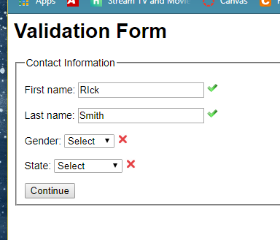

For State and Gender input boxes I edited the validate() function and added a selectCheck() function that returns false if a input drop box hasn’t had any selections made on it yet. Not sure why I had to create two selectCheck() functions to make it able put the “correct” or “incorrect” image separately on both Gender and State drop boxes. It didn’t work when I only used one selectCheck() function.

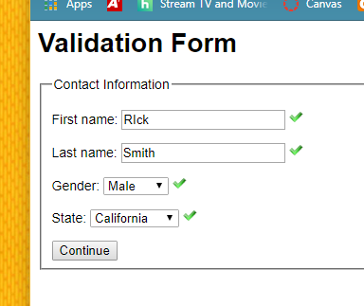

for the address code I borrowed it from the example in the zip folder

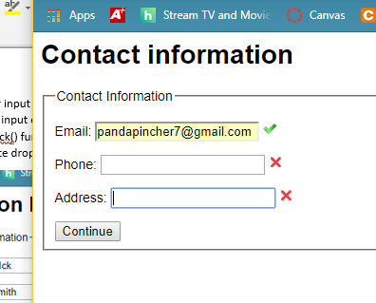

for the Phone number I had to do a little research on how to make regex’s but eventually got one made that worked for the formats xxx-xxx-xxxx and xxxxxxxxxx. Then I just threw in a an if statement to see if it matched the entry or not.

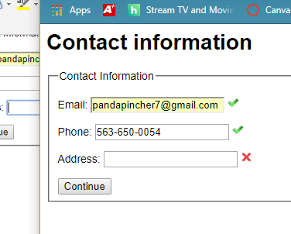

then for the Address I made another regex and had it only accept a word before the comma and then right after the comma, only two letters. No space between the comma though because that’s what it looked like in the example on the hw pdf. I could have made it require a space though.

